**Assignment -2**

|  |  |
| --- | --- |
| **Assignment Date** | 21 September 2022 |
| **Student Name** | Ms.JEYADARSHINI P |
| **Student Register Number** | 910619104034 |
| **Maximum Marks** |  |

In[1]:

**import** pandas **as** pd**import** numpy**as** np **import** seaborn**as** sns

**import** matplotlib.pyplot**as** plt

**%matplotlib**inline

**import**scipy.stats

*#import statsmodels.api as sms*

**import** statsmodels.formula.api**as** smf

**from** statsmodels.stats.stattools**import** jarque_bera

In[2]:

data**=**pd**.**read_csv('Churn_Modelling.csv') data

|  |  |  |  |  |  |  |  |  |  |  |
| --- | --- | --- | --- | --- | --- | --- | --- | --- | --- | --- |
| Out[2]: | **RowNumber** | **CustomerId** | **Surname** | **CreditScore** | **Geography** | **Gender** | **Age** | **Tenure** | **Balance** | **NumOfP** |
|  | **0** 1 | 15634602 | Hargrave | 619 | France | Female | 42 | 2 | 0.00 |  |
|  | **1** 2 | 15647311 | Hill | 608 | Spain | Female | 41 | 1 | 83807.86 |  |
|  | **2** 3 | 15619304 | Onio | 502 | France | Female | 42 | 8 | 159660.80 |  |
|  | **3** 4 | 15701354 | Boni | 699 | France | Female | 39 | 1 | 0.00 |  |
|  | **4** 5 | 15737888 | Mitchell | 850 | Spain | Female | 43 | 2 | 125510.82 |  |
|  | **...** ... | ... | ... | ... | ... | ... | ... | ... | ... |  |
|  | **9995** 9996 | 15606229 | Obijiaku | 771 | France | Male | 39 | 5 | 0.00 |  |
|  | **9996** 9997 | 15569892 | Johnstone | 516 | France | Male | 35 | 10 | 57369.61 |  |
|  | **9997** 9998 | 15584532 | Liu | 709 | France | Female | 36 | 7 | 0.00 |  |
|  | **9998** 9999 | 15682355 | Sabbatini | 772 | Germany | Male | 42 | 3 | 75075.31 |  |
|  | **9999** 10000 | 15628319 | Walker | 792 | France | Female | 28 | 4 | 130142.79 |  |

10000 rows × 14 columns

# Describe Function

In [7]:

data[['Age','Surname','Tenure','Balance']]**.**describe()

|  |  |  |  |
| --- | --- | --- | --- |
| Out[7]: | **Age** | **Tenure** | **Balance** |
|  | **count** 10000.000000 | 10000.000000 | 10000.000000 |
|  | **mean** 38.921800 | 5.012800 | 76485.889288 |
|  | **std** 10.487806 | 2.892174 | 62397.405202 |
|  | **min** 18.000000 | 0.000000 | 0.000000 |
|  | **25%** 32.000000 | 3.000000 | 0.000000 |
|  | **50%** 37.000000 | 5.000000 | 97198.540000 |
|  | **75%** 44.000000 | 7.000000 | 127644.240000 |
|  | **max** 92.000000 | 10.000000 | 250898.090000 |

# Data Type

Loading [MathJax]/extensions/Safe.js

|  |  |  |
| --- | --- | --- |
| In [15]: | data**.**dtypes |  |
| Out[15]: | RowNumber | int64 |
|  | CustomerId | int64 |
|  | Surname | object |
|  | CreditScore | int64 |
|  | Geography | object |
|  | Gender | object |
|  | Age | int64 |
|  | Tenure | int64 |
|  | Balance | float64 |
|  | NumOfProducts | int64 |
|  | HasCrCard | int64 |
|  | IsActiveMember | int64 |
|  | EstimatedSalary | float64 |
|  | Exited | int64 |
|  | dtype: object |  |
| In [16]: | data**.**isnull()**.**any() |  |
| Out[16]: | RowNumber | False |
|  | CustomerId | False |
|  | Surname | False |
|  | CreditScore | False |
|  | Geography | False |
|  | Gender | False |
|  | Age | False |
|  | Tenure | False |
|  | Balance | False |
|  | NumOfProducts | False |
|  | HasCrCard | False |
|  | IsActiveMember | False |
|  | EstimatedSalary | False |
|  | Exited | False |
|  | dtype: bool |  |

UNIVARIATE ANALYSIS

In [18]:

sns**.**histplot(data**.**Age,kde**=True**)

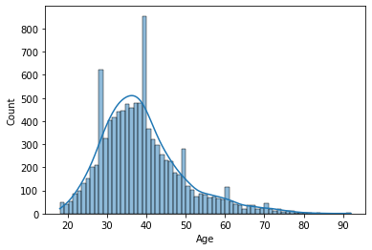Out[18]: <AxesSubplot:xlabel='Age', ylabel='Count'>

Loading [MathJax]/extensions/Safe.js

# BIVARIATE ANALYSIS

In [29]:

plt**.**boxplot(data**.**Balance) plt**.**show()

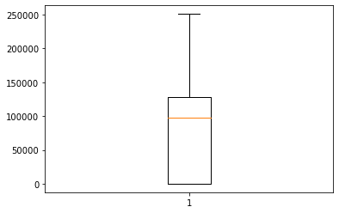

# MULTIVARIATE ANALYSIS

In [47]:

sns**.**pairplot(data)

Out[47]: <seaborn.axisgrid.PairGrid at 0x1cb8b759610>

Loading [MathJax]/extensions/Safe.js

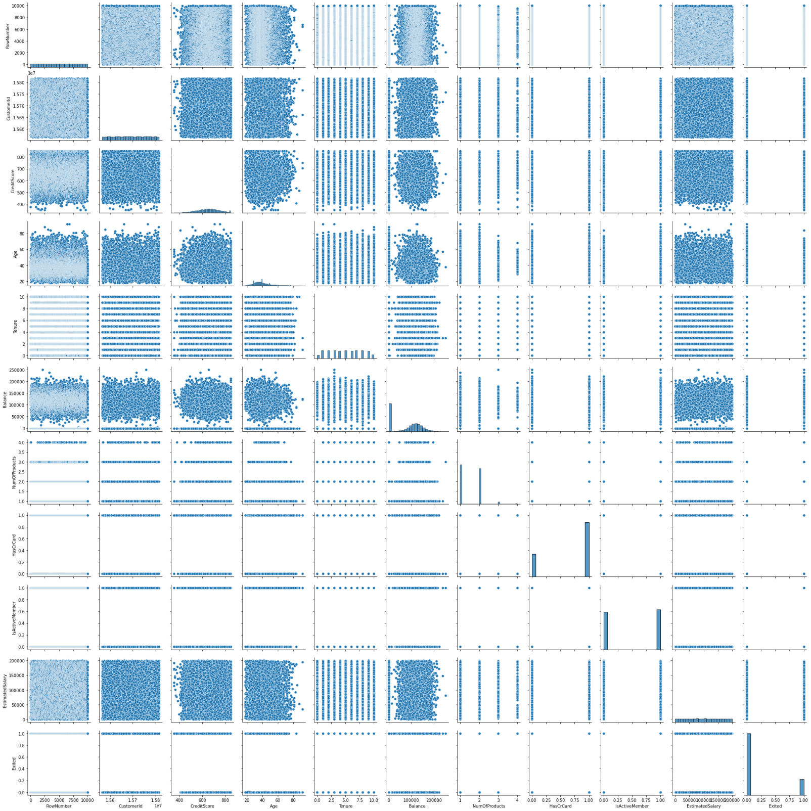

# Perform descriptive statistics on the dataset

In [3]:

data**.**describe(include**=**'all')

Loading [MathJax]/extensions/Safe.js

|  |  |  |  |  |  |  |  |  |  |
| --- | --- | --- | --- | --- | --- | --- | --- | --- | --- |
| Out[3]: |  | **RowNumber** | **CustomerId** | **Surname** | **CreditScore** | **Geography** | **Gender** | **Age** | **Tenure** |
|  | **count** | 10000.00000 | 1.000000e+04 | 10000 | 10000.000000 | 10000 | 10000 | 10000.000000 | 10000.000000 |
|  | **unique** | NaN | NaN | 2932 | NaN | 3 | 2 | NaN | NaN |
|  | **top** | NaN | NaN | Smith | NaN | France | Male | NaN | NaN |
|  | **freq** | NaN | NaN | 32 | NaN | 5014 | 5457 | NaN | NaN |
|  | **mean** | 5000.50000 | 1.569094e+07 | NaN | 650.528800 | NaN | NaN | 38.921800 | 5.012800 |
|  | **std** | 2886.89568 | 7.193619e+04 | NaN | 96.653299 | NaN | NaN | 10.487806 | 2.892174 |
|  | **min** | 1.00000 | 1.556570e+07 | NaN | 350.000000 | NaN | NaN | 18.000000 | 0.000000 |
|  | **25%** | 2500.75000 | 1.562853e+07 | NaN | 584.000000 | NaN | NaN | 32.000000 | 3.000000 |
|  | **50%** | 5000.50000 | 1.569074e+07 | NaN | 652.000000 | NaN | NaN | 37.000000 | 5.000000 |
|  | **75%** | 7500.25000 | 1.575323e+07 | NaN | 718.000000 | NaN | NaN | 44.000000 | 7.000000 |
|  | **max** | 10000.00000 | 1.581569e+07 | NaN | 850.000000 | NaN | NaN | 92.000000 | 10.000000 |
| In [4]: | data**.**count() | |  | | | | | | |
| Out[4]: | RowNumber | | 10000 | | | | | | |
|  | CustomerId | | 10000 | | | | | | |
|  | Surname | | 10000 | | | | | | |
|  | CreditScore | | 10000 | | | | | | |
|  | Geography | | 10000 | | | | | | |
|  | Gender | | 10000 | | | | | | |
|  | Age | | 10000 | | | | | | |
|  | Tenure | | 10000 | | | | | | |
|  | Balance | | 10000 | | | | | | |
|  | NumOfProducts | | 10000 | | | | | | |
|  | HasCrCard | | 10000 | | | | | | |
|  | IsActiveMember | | 10000 | | | | | | |
|  | EstimatedSalary | | 10000 | | | | | | |
|  | Exited  dtype: int64 | | 10000 | | | | | | |

# Handle the Missing values.

Fill with Zeros for NAN values

In [7]:

a **=**data**.**fillna(0) a

Loading [MathJax]/extensions/Safe.js

|  |  |  |  |  |  |  |  |  |  |  |
| --- | --- | --- | --- | --- | --- | --- | --- | --- | --- | --- |
| Out[7]: | **RowNumber** | **CustomerId** | **Surname** | **CreditScore** | **Geography** | **Gender** | **Age** | **Tenure** | **Balance** | **NumOfP** |
|  | **0** 1 | 15634602 | Hargrave | 619 | France | Female | 42 | 2 | 0.00 |  |
|  | **1** 2 | 15647311 | Hill | 608 | Spain | Female | 41 | 1 | 83807.86 |  |
|  | **2** 3 | 15619304 | Onio | 502 | France | Female | 42 | 8 | 159660.80 |  |
|  | **3** 4 | 15701354 | Boni | 699 | France | Female | 39 | 1 | 0.00 |  |
|  | **4** 5 | 15737888 | Mitchell | 850 | Spain | Female | 43 | 2 | 125510.82 |  |
|  | **...** ... | ... | ... | ... | ... | ... | ... | ... | ... |  |
|  | **9995** 9996 | 15606229 | Obijiaku | 771 | France | Male | 39 | 5 | 0.00 |  |
|  | **9996** 9997 | 15569892 | Johnstone | 516 | France | Male | 35 | 10 | 57369.61 |  |
|  | **9997** 9998 | 15584532 | Liu | 709 | France | Female | 36 | 7 | 0.00 |  |
|  | **9998** 9999 | 15682355 | Sabbatini | 772 | Germany | Male | 42 | 3 | 75075.31 |  |
|  | **9999** 10000 | 15628319 | Walker | 792 | France | Female | 28 | 4 | 130142.79 |  |

In [13]:

Loading [MathJax]/extensions/Safe.js

cols **=**3

rows **=**4

num_cols**=**data**.**select_dtypes(exclude**=**'object')**.**columns fig **=** plt**.**figure( figsize**=**(cols**\***5, rows**\***5))

**for** i, col **in** enumerate(num_cols):

10000 rows × 14 columns

# Find the outliers and replace the outliers

In [8]:

a

|  |  |  |  |  |  |  |  |  |  |  |
| --- | --- | --- | --- | --- | --- | --- | --- | --- | --- | --- |
| Out[8]: | **RowNumber** | **CustomerId** | **Surname** | **CreditScore** | **Geography** | **Gender** | **Age** | **Tenure** | **Balance** | **NumOfP** |
|  | **0** 1 | 15634602 | Hargrave | 619 | France | Female | 42 | 2 | 0.00 |  |
|  | **1** 2 | 15647311 | Hill | 608 | Spain | Female | 41 | 1 | 83807.86 |  |
|  | **2** 3 | 15619304 | Onio | 502 | France | Female | 42 | 8 | 159660.80 |  |
|  | **3** 4 | 15701354 | Boni | 699 | France | Female | 39 | 1 | 0.00 |  |
|  | **4** 5 | 15737888 | Mitchell | 850 | Spain | Female | 43 | 2 | 125510.82 |  |
|  | **...** ... | ... | ... | ... | ... | ... | ... | ... | ... |  |
|  | **9995** 9996 | 15606229 | Obijiaku | 771 | France | Male | 39 | 5 | 0.00 |  |
|  | **9996** 9997 | 15569892 | Johnstone | 516 | France | Male | 35 | 10 | 57369.61 |  |
|  | **9997** 9998 | 15584532 | Liu | 709 | France | Female | 36 | 7 | 0.00 |  |
|  | **9998** 9999 | 15682355 | Sabbatini | 772 | Germany | Male | 42 | 3 | 75075.31 |  |
|  | **9999** 10000 | 15628319 | Walker | 792 | France | Female | 28 | 4 | 130142.79 |  |

10000 rows × 14 columns

In [9]:

missing_values**=**data**.**isnull()**.**sum() missing_values[missing_values**>**0]**/**len(data)**\***100

Out[9]: Series([], dtype:float64)

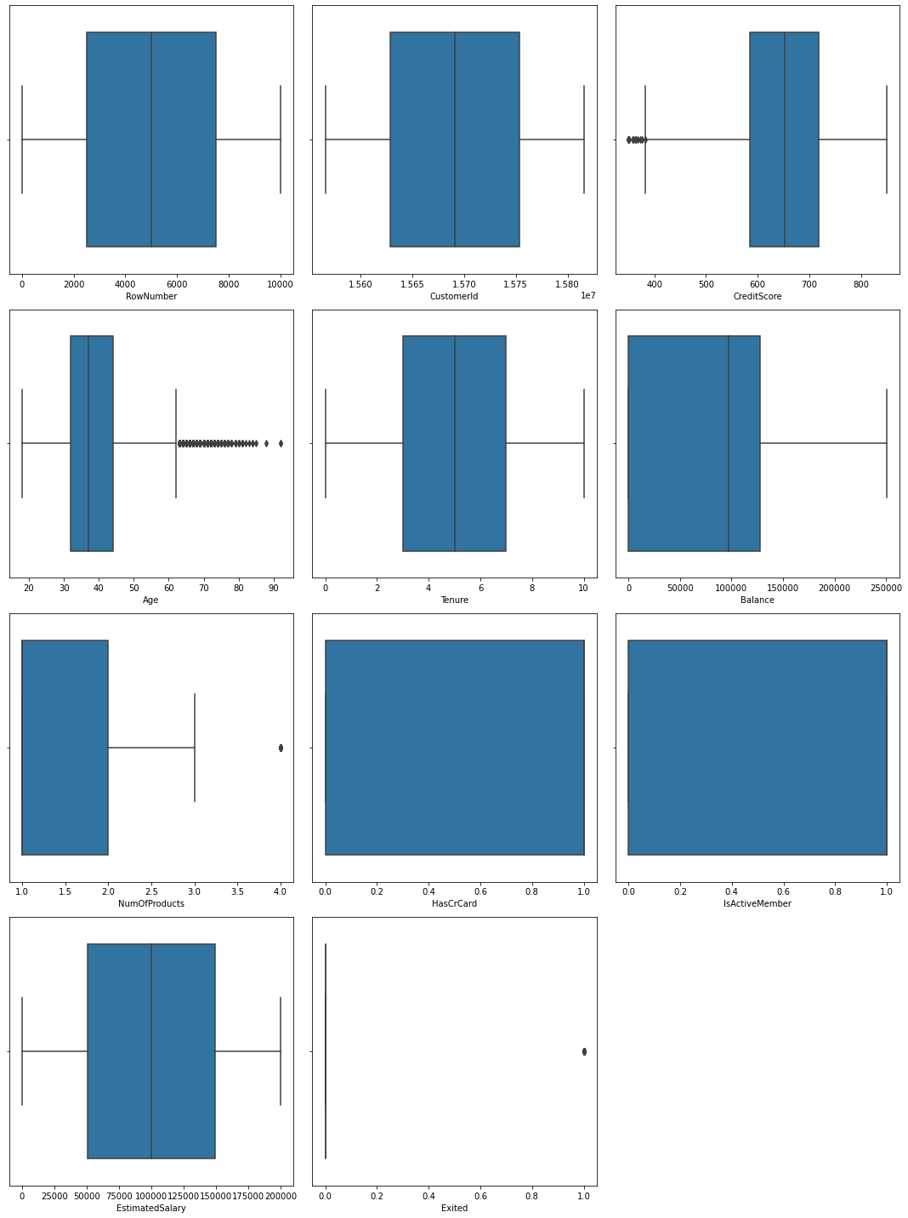

ax**=**fig**.**add_subplot(rows,cols,i**+**1) sns**.**boxplot(x**=**data[col],ax**=**ax)

fig**.**tight_layout() plt**.**show()

Loading [MathJax]/extensions/Safe.js

In [14]:

data['CreditScore']**.**hist()

Out[14]:

In[15]:

<AxesSubplot:>

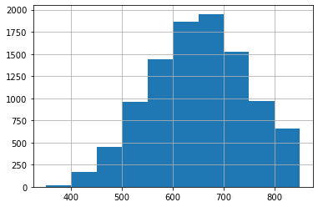

In [4]:

Loading [MathJax]/extensions/Safe.js

**import** numpy**as** np *#for numpy operations*

**import** pandas **as** pd*#for creating DataFrame using Pandas # to split the dataset using sklearn*

**from** sklearn.model_selection**import** train_test_split

*# load titanic dataset*

data1 **=** pd**.**read_csv('Churn_Modelling.csv',

Skewness value of Age: 1.0113202630234552 Mean of Age is:38.9218

print('SkewnessvalueofAge:',data['Age']**.**skew()) Age_mean**=**data['Age']**.**mean()

print('Mean of Age is:',Age_mean) Age_std**=** data['Age']**.**std()

print('Standard Deviation of Age is: ',Age_std) low**=** Age_mean**-**(3 **\*** Age_std)

high**=** Age_mean**+** (3 **\*** Age_std)

Age_outliers**=** data[(data['Age'] **<**low) **|** (data['Age'] **>**high)]

*#print('OutliersofAgeis:\n',Age_outliers)* print('Outliers of Age is:') Age_outliers**.**head()

Standard Deviation of Age is: 10.487806451704591 Outliers of Age is:

|  |  |  |  |  |  |  |  |  |  |  |
| --- | --- | --- | --- | --- | --- | --- | --- | --- | --- | --- |
| Out[15]: | **RowNumber** | **CustomerId** | **Surname** | **CreditScore** | **Geography** | **Gender** | **Age** | **Tenure** | **Balance** | **NumOfPro** |
|  | **85** 86 | 15805254 | Ndukaku | 652 | Spain | Female | 75 | 10 | 0.00 |  |
|  | **158** 159 | 15589975 | Maclean | 646 | France | Female | 73 | 6 | 97259.25 |  |
|  | **230** 231 | 15808473 | Ringrose | 673 | France | Male | 72 | 1 | 0.00 |  |
|  | **252** 253 | 15793726 | Matveyeva | 681 | France | Female | 79 | 0 | 0.00 |  |
|  | **310** 311 | 15712287 | Pokrovskii | 652 | France | Female | 80 | 4 | 0.00 |  |

# Check for Categorical columns and perform encoding.

In [ ]:

*#data1=pd.read_csv('Churn_Modelling.csv') #data1.head()*

usecols**=**['Surname','Gender','Geography']) data1**.**head()

|  |  |  |  |  |
| --- | --- | --- | --- | --- |
| Out[4]: |  | **Surname** | **Geography** | **Gender** |
|  | **0** | Hargrave | France | Female |
|  | **1** | Hill | Spain | Female |
|  | **2** | Onio | France | Female |
|  | **3** | Boni | France | Female |
|  | **4** | Mitchell | Spain | Female |

In [5]:

pd**.**get_dummies(data1)

|  |  |  |  |  |  |  |
| --- | --- | --- | --- | --- | --- | --- |
| Out[5]: | **Surname_Abazu** | **Surname_Abbie** | **Surname_Abbott** | **Surname_Abdullah** | **Surname_Abdulov** | **Surname_Abel** |
|  | **0** 0 | 0 | 0 | 0 | 0 | 0 |
|  | **1** 0 | 0 | 0 | 0 | 0 | 0 |
|  | **2** 0 | 0 | 0 | 0 | 0 | 0 |
|  | **3** 0 | 0 | 0 | 0 | 0 | 0 |
|  | **4** 0 | 0 | 0 | 0 | 0 | 0 |
|  | **...** ... | ... | ... | ... | ... | ... |
|  | **9995** 0 | 0 | 0 | 0 | 0 | 0 |
|  | **9996** 0 | 0 | 0 | 0 | 0 | 0 |
|  | **9997** 0 | 0 | 0 | 0 | 0 | 0 |
|  | **9998** 0 | 0 | 0 | 0 | 0 | 0 |
|  | **9999** 0 | 0 | 0 | 0 | 0 | 0 |

10000 rows × 2937 columns

In [17]:

*# Returns dictionary having key as category and values asnumber*

**def**find_category_mappings(data, variable):

**return** {k: i **for** i, k **in**enumerate(data[variable]**.**unique())}

*# Returns the column after mapping with dictionary*

**def**integer_encode(data,variable, ordinal_mapping): data[variable]**=**data[variable]**.**map(ordinal_mapping)

**for** variable **in** ['Surname','Geography','Gender']: mappings**=**find_category_mappings(data1,variable) integer_encode(data1, variable, mappings)

data1**.**head()

|  |  |  |  |
| --- | --- | --- | --- |
| Out[17]: | **Surname** | **Geography** | **Gender** |
|  | **0** 0 | 0 | 0 |
|  | **1** 1 | 1 | 0 |
|  | **2** 2 | 0 | 0 |
|  | **3** 3 | 0 | 0 |
|  | **4** 4 | 1 | 0 |

# Split the data into dependent and independent

Loading [MathJax]/extensions/Safe.js

# variables.

Dependent Variable : A dependent variable is a variable whose value depends on another variable.

Independent Variable : An Independent variable is a variable whose value never depends on another variable.

In [6]:

print("TheMinimumvalueofDataset:\n",data1**.**min(numeric_only**=True**)) print("\n")

print("TheMaximumvalueofDataset:\n",data1**.**max(numeric_only**=True**)) print("\n")

print("TheMeanvalueofDataset:\n",data1**.**mean(numeric_only**=True**)) print("\n")

print(data1**.**count(0)) print(data1**.**shape) print(data1**.**size)

The Minimum value ofDataset: Series([], dtype:float64)

The Maximum value ofDataset: Series([], dtype:float64)

The Mean value of Dataset: Series([], dtype:float64)

|  |  |
| --- | --- |
| Surname | 10000 |
| Geography | 10000 |
| Gender dtype: int64  (10000, 3) | 10000 |
| 30000 |  |

In [7]:

y **=** data1["Surname"] x**=**data1**.**drop(columns**=**["Surname"],axis**=**1) x**.**head()

|  |  |  |  |
| --- | --- | --- | --- |
| Out[7]: |  | **Geography** | **Gender** |
|  | **0** | France | Female |
|  | **1** | Spain | Female |
|  | **2** | France | Female |
|  | **3** | France | Female |
|  | **4** | Spain | Female |

# Scale the independent variables

Loading [MathJax]/extensions/Safe.js

In[8]:

In [21]: x_train**.**shape

,y_train**.**shape,x_test**.**shape,y_test**.**shape

names**=**x**.**columnsnames

Out[8]: Index(['Geography', 'Gender'],dtype='object') In[12]:

**from** sklearn.preprocessing**import**scale x**=**scale(x)

In[16]:

x

|  |  |  |  |
| --- | --- | --- | --- |
| Out[16]: |  | **Geography** | **Gender** |
|  | **0** | France | Female |
|  | **1** | Spain | Female |
|  | **2** | France | Female |
|  | **3** | France | Female |
|  | **4** | Spain | Female |
|  | **...** | ... | ... |
|  | **9995** | France | Male |
|  | **9996** | France | Male |
|  | **9997** | France | Female |
|  | **9998** | Germany | Male |
|  | **9999** | France | Female |

10000 rows × 2 columns

# Split the data into training and testing

The train-test split is used to estimate the performance of machine learning algorithms that are applicable for prediction-based Algorithms/Applications. By default, the Test set is split into 30 % of actual data and the training set is split into 70% of the actual data.

In[18]:

**from** sklearn.model_selection**import** train_test_split

In[19]:

x_train,x_test,y_train,y_test**=**train_test_split(x,y,test_size**=**0.2,random_state**=**0)

In[20]:

x_train**.**head()

|  |  |  |  |
| --- | --- | --- | --- |
| Out[20]: |  | **Geography** | **Gender** |
|  | **7389** | Spain | Female |
|  | **9275** | Germany | Male |
|  | **2995** | France | Female |
|  | **5316** | Spain | Male |
|  | **356** | Spain | Female |

Loading [MathJax]/extensions/Safe.js

Out[21]: ((8000, 2), (8000,), (2000, 2), (2000,))

Loading [MathJax]/extensions/Safe.js